# Data collected

**This is the statistics collected on Jasprit Bumrah from IPLT20.com for the year 2019**

|  |  |  |  |  |  |  |
| --- | --- | --- | --- | --- | --- | --- |
| **Match no** | **WinLoss** | **Overs** | **Runs conceded** | **Wickets** | **Bowling economy** | **Dot Balls** |
| 1 | L | 4 | 40 | 1 | 10.00 | 8 |
| 2 | W | 4 | 20 | 3 | 5 | 14 |
| 3 | L | 3.4 | 23 | 0 | 6.27 | 12 |
| 4 | W | 4 | 27 | 0 | 6.75 | 12 |
| 5 | W | 3 | 16 | 1 | 5.33 | 9 |
| 6 | L | 4 | 38 | 1 | 9.5 | 9 |
| 7 | W | 4 | 23 | 2 | 5.75 | 12 |
| 8 | W | 4 | 22 | 0 | 5.5 | 14 |
| 9 | L | 4 | 18 | 2 | 4.5 | 13 |
| 10 | W | 4 | 21 | 1 | 5.25 | 8 |
| 11 | W | 3 | 10 | 2 | 3.33 | 12 |
| 12 | L | 4 | 44 | 0 | 11 | 6 |
| 13 | W | 4 | 31 | 2 | 7.75 | 9 |
| 14 | W | 4 | 31 | 2 | 7.75 | 12 |
| 15 | W | 4 | 31 | 0 | 7.75 | 6 |

**This is the statistics collected on Rashid Khan from IPLT20.com for the year 2019**

|  |  |  |  |  |  |  |
| --- | --- | --- | --- | --- | --- | --- |
| Match no | WinLoss | Overs | Runs conceded | Wickets | Bowling economy | Dot balls |
| 1 | L | 4 | 26 | 1 | 6.5 | 10 |
| 2 | W | 4 | 24 | 1 | 6 | 10 |
| 3 | W | 4 | 25 | 0 | 6.25 | 10 |
| 4 | W | 4 | 18 | 1 | 4.5 | 13 |
| 5 | L | 4 | 27 | 1 | 6.75 | 13 |
| 6 | L | 4 | 20 | 1 | 5 | 9 |
| 7 | L | 4 | 22 | 1 | 5.5 | 11 |
| 8 | W | 4 | 17 | 2 | 4.25 | 13 |
| 9 | W | 4 | 23 | 1 | 5.75 | 12 |
| 10 | L | 4 | 44 | 1 | 11 | 7 |
| 11 | L | 4 | 30 | 1 | 7.5 | 10 |
| 12 | W | 4 | 21 | 3 | 5.25 | 12 |
| 13 | L | 4 | 21 | 0 | 5.25 | 11 |
| 14 | L | 4 | 44 | 1 | 11 | 9 |
| 15 | L | 4 | 15 | 2 | 3.75 | 16 |

I am considering only 15 matches as Rashid played 15 and Bumrah played 16. So for the comparison I am taking data from only 15 matches.

# Data Analysis

1. Number of runs conceded by Bumrah and Rashid in 15 matches.

Average number of runs conceded by Bumrah=26.333

Average number of runs conceded by Rashid =25.1333

Total number of runs conceded by Bumrah =395

Total number of runs conceded by Rashid =377

1. Bowling economy per match

Average bowling economy of Bumrah=6.76

Average bowling economy of Rashid =6.2833

1. Number of wickets per match

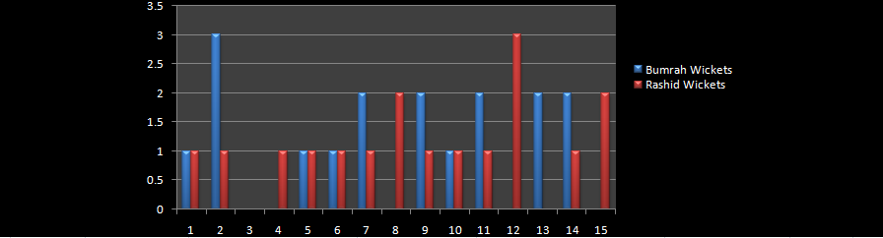

Total number of wickets taken by Bumrah =17

Total number of wickets taken by Rashid =17

Both of them did not take any wicket in their respective 3rd match

1. Number of dot balls per match

Total number of dot balls by Bumrah =156

Total number of dot balls by Rashid =166

Average number of dot balls by Bumrah =10.4

Average number of dot balls by Rashid =11.07

1. Number of overs

Total number of overs bowled by Bumrah =57.4

Total number of overs bowled by Rashid =60

# Matches their team won

**Matches which Bumrah’s team won**

|  |  |  |  |  |  |  |
| --- | --- | --- | --- | --- | --- | --- |
| **Match no** | **WinLoss** | **Overs** | **Runs conceded** | **Wickets** | **Bowling economy** | **dots** |
| 2 | W | 4 | 20 | 3 | 5 | 14 |
| 4 | W | 4 | 27 | 0 | 6.75 | 12 |
| 5 | W | 3 | 16 | 1 | 5.33 | 9 |
| 7 | W | 4 | 23 | 2 | 5.75 | 12 |
| 8 | W | 4 | 22 | 0 | 5.5 | 14 |
| 10 | W | 4 | 21 | 1 | 5.25 | 8 |
| 11 | W | 3 | 10 | 2 | 3.33 | 12 |
| 13 | W | 4 | 31 | 2 | 7.75 | 9 |
| 14 | W | 4 | 31 | 2 | 7.75 | 12 |
| 15 | W | 4 | 31 | 0 | 7.75 | 6 |

Matches which Rashid’s team won

|  |  |  |  |  |  |  |
| --- | --- | --- | --- | --- | --- | --- |
| Match no | WinLoss | Overs | Runs conceded | Wickets | Bowling economy | Dot balls |
| 2 | W | 4 | 24 | 1 | 6 | 10 |
| 3 | W | 4 | 25 | 0 | 6.25 | 10 |
| 4 | W | 4 | 18 | 1 | 4.5 | 13 |
| 8 | W | 4 | 17 | 2 | 4.25 | 13 |
| 9 | W | 4 | 23 | 1 | 5.75 | 12 |
| 12 | W | 4 | 21 | 3 | 5.25 | 12 |

Number of matches Bumrah won =10

Number of matches Rashid won =6

Number of wickets Bumrah took =13

Number of wickets Rashid took =8

Overs Bumrah bowled =38

Overs Rashid bowled =24

Bumrah average bowling economy=6.016

Rashid average bowling economy=5.33

Bumrah runs conceded =212

Rashid runs conceded =128

Bumrah dot balls =108

Rashid dot balls =70

**If there are Bumrah type bowlers bowling with the same economy then you will have to chase the target of 120**.

**If there are Rashid type bowlers bowling with the same economy then you will have to chase the target of 100.**

THEREFORE RASHID BOWLED BETTER IN WINNING MATCHES THEN BUMRAH.